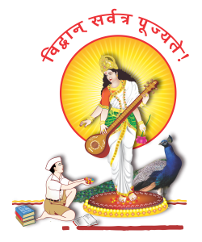

P.V.G’s College of Science & Commerce, Pune-9

Department of Computer Science

Project Certificate

This is to certify that Sai Phapale, Varad karve , Swaraj Bhagat of S.Y.M.Sc Computer Science, Computer, Semester-IV has satisfactorily completed the Industrial Training / Institutional Project under the course CS/CA/DS-651-MJP, in the academic year 2025-2026, as prescribed by Savitribai Phule Pune University.
The title of the project is
ERP Authentication Module


Project Guide HOD

Internal Examiner Industry Expert External Examiner

